Algorithm and data Analysis

[Logistic regression](https://www.statisticssolutions.com/free-resources/directory-of-statistical-analyses/logistic-regression/) is the appropriate regression analysis to conduct when the dependent variable is dichotomous (binary).  Like all regression analyses, the logistic regression is a predictive analysis.  Logistic regression is used to describe data and to explain the relationship between one dependent binary variable and one or more nominal, ordinal, interval or ratio-level independent variables

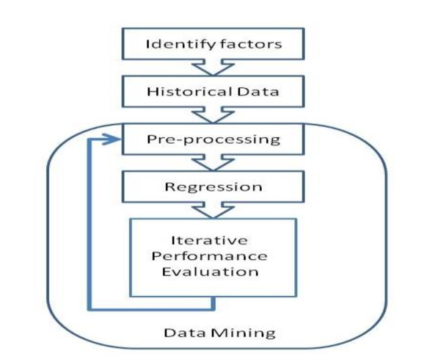To determine the rate of increase or decrease of request per month, year and Barangay. Using historical data, we can predict the what barangay has the most requester and what month or year base on different factors.

1.**Identify Factors:** The first step in building the regression model is to identify a super-set of potential factors or attributes that may influence the rate of request

2. **Historical Data**: Once a set of potential attributes have been determined, the next step in the process is to gather historical records.

3. **Data Mining:** In this key step, we build the multivariate logistic regression model using the historical data, evaluate the model’s performance, and iteratively refine the model as needed.

* **Pre-Processing:** Some pre-processing of the data may be needed prior to application of the logistic regression algorithm. In particular, processing may be needed to ensure that each regressor is a strictly numerical or strictly categorical quantity.
* **Regression:** After pre-processing the historical records, we develop the multivariate logistic regression. This particular algorithm predicts a categorical variable of interest in terms of multiple independent attributes. The independent attributes can be either numeric or categorical quantities.
* **Iterative Performance Evaluation:** The final step is to test the performance by comparing its prediction against actual report.